**Scoreboard**

**Model: LD**

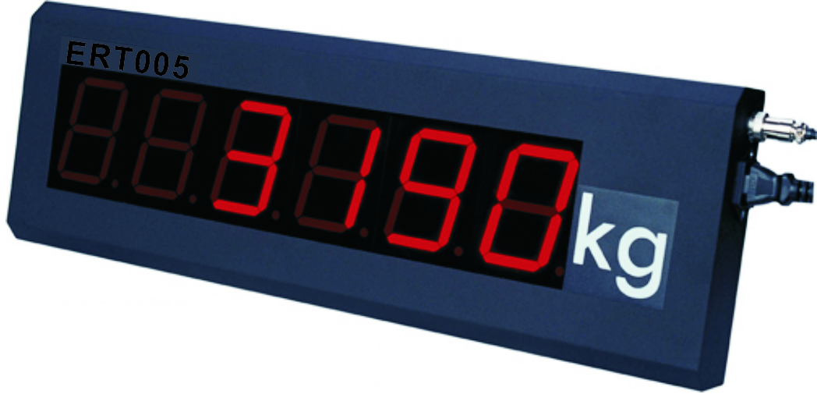 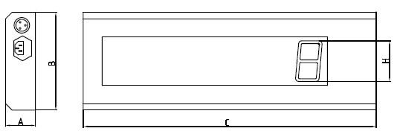

**Size:**

|  |  |  |  |  |
| --- | --- | --- | --- | --- |
| **Model** | **A(mm)** | **B(mm)** | **C(mm)** | **H(mm)** |
| LD3 | 55 | 180 | 540 | 75 |
| LD5 | 58 | 260 | 780 | 125 |

**Feature:**

* Dynamic scan flip-latching technology (LD3/5)
* High-lighted digital segment and broad eyesight with special optical filter film
* Gross or net weight display from indictor  or other output system
* Display character: 6-bit LED with character height 75mm (LD3 steel housing)
* Display character: 6-bit LED with character height 125mm (LD5 steel housing)
* Power：AC 187～242V；49～51Hz
* Communication： RS232 output
* Temperature:-10℃～40℃
* Humility: ≤85％RH