**Wireless Dynamometer**

**Model: AL-W5**

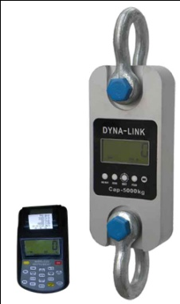 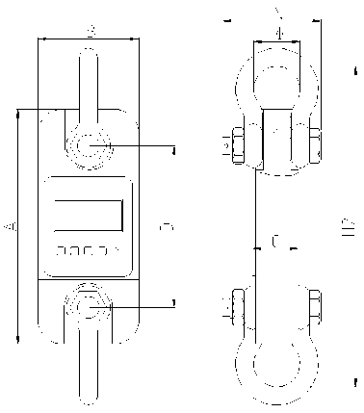

**DIMENSIONS*(Dimensions shown are nominal and subject to tolerances)***

|  |  |  |  |  |  |  |  |  |  |
| --- | --- | --- | --- | --- | --- | --- | --- | --- | --- |
| MODEL | CAP | Div | A  (mm) | B  (mm) | C  (mm) | D  (mm) | Φ  (mm) | H  (mm) | Material |
| AL-W5-1 | 1t | 0.5kg | 245 | 112 | 37 | 190 | 43 | 335 | Aluminum |
| AL-W5-2 | 2t | 1kg | 260 | 123 | 37 | 195 | 51 | 365 | Aluminum |
| AL-W5-3 | 3t | 1kg | 260 | 123 | 37 | 195 | 51 | 365 | Aluminum |
| AL-W5-5 | 5t | 2kg | 285 | 123 | 57 | 210 | 58 | 405 | Aluminum |
| AL-W5-10 | 10t | 5kg | 320 | 120 | 57 | 230 | 92 | 535 | Alloy Steel |
| AL-W5-20 | 20t | 10kg | 375 | 128 | 74 | 260 | 127 | 660 | Alloy Steel |
| AL-W5-30 | 30t | 10kg | 420 | 138 | 82 | 280 | 146 | 740 | Alloy Steel |
| AL-W5-50 | 50t | 20kg | 465 | 150 | 104 | 305 | 184 | 930 | Alloy Steel |
| AL-W5-100 | 100t | 50kg | 570 | 190 | 132 | 366 | 229 | 1230 | Alloy Steel |
| AL-W5-200 | 200t | 100kg | 720 | 265 | 183 | 440 | 280 | 1362 | Alloy Steel |

**WEIGHTS**

|  |  |  |  |  |  |
| --- | --- | --- | --- | --- | --- |
| **Model** | AL-W5-1 | AL-W5-2 | AL-W5-3 | AL-W5-5 | AL-W5-10 |
| **Unit Weight(kg)** | 1.6 | 2.1 | 2.1 | 2.7 | 10.4 |
| **Weight with shackles(kg)** | 3.1 | 4.6 | 4.6 | 6.3 | 24.8 |
| **Model** | AL-W5-20 | AL-W5-30 | AL-W5-50 | AL-W5-100 | AL-W5-200 |
| **Unit Weight(kg)** | 17.8 | 25 | 39 | 81 | 210 |
| **Weight with shackles(kg)** | 48.6 | 73 | 128 | 321 | 776 |

**Profile:**

AL-W5 wireless dynamometer is an extremely well-built instrument for industry use, as a standard wireless tool offer universal applications, whether used as conventional crane weigher or to measure force, AL-W5 wireless dynamometer is the latest design, compatible with the concept of portable, print and easy to operate. Shoulder bag style leather case, easy to carry, suitable for protected outdoor use., calibration is easier with 58 indicator.

**Features:**

* **Body protection:** Aluminum and alloy steel capacities are powder coated.
* **Accuracy:** 0.05% for 1-50t, 0.1% for above 50t capacity.
* **Units:** Units are clearly display on the screen**,** available in the following measurment reading: kilograms(kg), short Tons(t) pounds(lb), Newton and kilonewton(kN)
* **Shackles:** High tension industrial standard G2130 anchor shackle bows, galvanized finish.
* **Gravity regulation:** The acceleration of gravity can be regulated through indicator parameter setting according to different places value.
* **Functions:** wireless indicator with many functions: Zero, tare, Low battery warnings, peak hold, overload warning. User calibration(with password).
* **Set-Point:** Two user programmable Set-Point can be used for safety and warning applications or for limit weighing.
* **Body indicator key:** 4 local mechanical keys:”ON/OFF”,”ZERO”,”PEAK” and ”Unit Change”.
* **Indicator communications:** Both RS232 serial port and USB port，solve most laptops without serial port problem. with the Everight company’s PC host computer software,not only display weigh value and stable information on the PC ,can also enter company’s name,complete storage ,print query and other functions .
* **Antenna:** Internal antenna
* **Function on indicator keyboard:** It can print data,time,Serial number, commodity number,net weight and total weight. Also can input 16 digits head information,It can store up to 2000 weighing records.It can be statistics by serial number or commodity number，also can statistics by data, statistical results can be printed with weighing number and total weight.

**Main technical data:**

|  |  |
| --- | --- |
| Body Display | 25mm (1’’) 5digits LCD with backlight |
| Indicator Display | 25mm (1’’) 5digits LCD with backlight |
| Power on zero range | 20% F.S. |
| Manual Zero Range | 4% F.S. |
| Tare Range | 100% F.S. |
| Stable Time | ≤5 seconds |
| Overload Indication | 100% F.S. + 9e |
| Max. Safety Load | 125% F.S. |
| Ultimate Load | 400% F.S. |
| Battery Life | ≥50 hours |
| Body Battery | “LR6(AA)”size alkaline batteries. 1.5Vⅹ3 |
| Indicator Battery | Rechargable Ni-H battery, SC 3.3Ah |
| Operating Temp. | - 20℃ ~ + 50℃ |
| Operating Humidity | ≤85% RH under 20℃ |
| Indicator printer | FUJITSU FTP-628 MCL101#50″ high speed thermal printer |
| Wireless Distance | Min. 80m(default) [200m(optional)] |
| Wireless Frequency | 2.4GHz(default),433MHz,868MHz(optional), up to 128 channels available |