**Wireless Heat Proof Crane Scale**

**Dimensions and Specifications: Model: OCS-AWH2**

|  |  |  |  |  |  |  |  |  |  |
| --- | --- | --- | --- | --- | --- | --- | --- | --- | --- |
| **MODEL** | **Cap.**  **(kg)** | **Resolution**  **(kg)** | **A**  **(mm)** | **C**  **(mm)** | **E**  **(mm)** | **H**  **(mm)** | **Φ1**  **(mm)** | **Φ2**  **(mm)** | **OCS-SWH2G.W.**  **(kg)** |
| **OCS-AWH2-1** | 1000 | 0.5 | 67 | 35 | 160 | 450 | 270 | 400 | 45 |
| **OCS-AWH2-2** | 2000 | 1 | 95 | 45 | 160 | 510 | 270 | 400 | 47 |
| **OCS-AWH2-3** | 3000 | 1 | 113 | 55 | 185 | 625 | 270 | 520 | 53 |
| **OCS-AWH2-5** | 5000 | 2 | 122 | 65 | 185 | 710 | 325 | 520 | 62 |
| **OCS-AWH2-10** | 10000 | 5 | 144 | 70 | 185 | 835 | 325 | 520 | 87 |
| **OCS-AWH2-15** | 15000 | 5 | 166 | 85 | 185 | 900 | 325 | 520 | 100 |
| **OCS-AWH2-20** | 20000 20000 | 10 | 260 | 90 | 200 | 1055 | 325 | 620 | 130 |
| **OCS-AWH2-30** | 30000 20000 | 10 | 285 | 100 | 220 | 1140 | 375 | 620 | 210 |
| **OCS-AWH2-50** | 50000 20000 | 20 | 360 | 160 | 280 | 1680 | 450 | 750 | 575 |

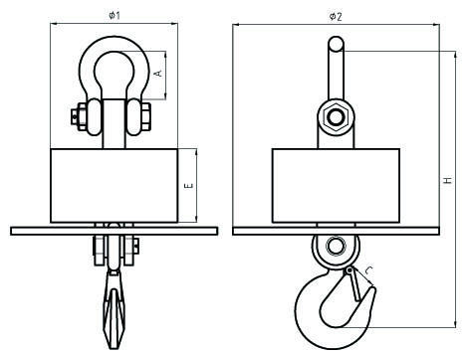**Min distance between scale and high temperature:**

|  |  |  |  |
| --- | --- | --- | --- |
| **1000℃** | **1200℃** | **1400℃** | **1600℃** |
| **1.6m** | **1.8m** | **2m** | **2.2m** |

**Features：**

* Steel plate with heat-resistant material inside.
* Seamless steel pipe enclosure for maximum protection.
* Manu operation mode, calibration, saving, searching, peak hold,

easy to operate.

* Indicator Adopts ∑-Δ A/D conversion technology.
* Weighing data save protection in case of power off.
* Battery charger with several protection modes to extend life of rechargeable battery.
* Standard RS232 communication interface(optional).
* Portable design, indicator packed in portable carry case, easy to operate outdoor.
* Gathering up to data records of 99 weighings, records can be sorted, searched .
* Power saving mode, indicator will turn off automatically after 30minutes with no operation.
* With 32 channels optional, so 32 crane scales can operated independently in the same airplace without interface.

**Main technical data：**

|  |  |
| --- | --- |
| Accuracy Standard | According to OIML class III |
| Display | LCD with backlight |
| Wireless Distance | Up to 200m without obstacle |
| Filtering | Low, Medium or High selectable |
| Resulation | 2000 to 3000 divisions standard(up to 15,000 available) |
| Zero Range | Auto/Manual setting, from 4% to 100%. |
| Tare Range | 100% F.S. |
| Overload Indication | 100% F.S. + 9e |
| Max. Safety Load | 125% F.S. |
| Ultimate Load | 700% F.S. |
| Scale Battery Type | DC 6V/4Ah rechargeable Ni-H battery |
| Indicator Battery | 4.8V/2.8Ah rechargeable Ni-H battery |
| Battery charger | Input: AC100-240V 50/60Hz Output: 850mA |
| Operating Temperature Range | - 20℃ ~ + 50℃ |
| Operating Humidity | ≤85% RH under 20℃ |
| Radio Frequency | 433MHz |