**Wireless weighing Indicator**

**Model: 28 Accessories:**

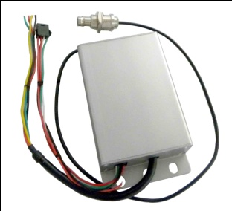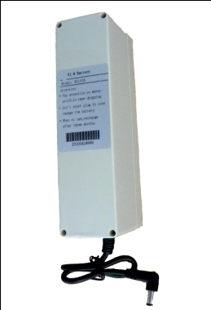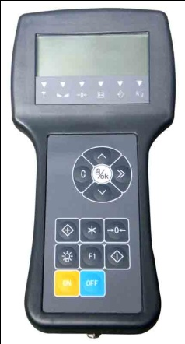 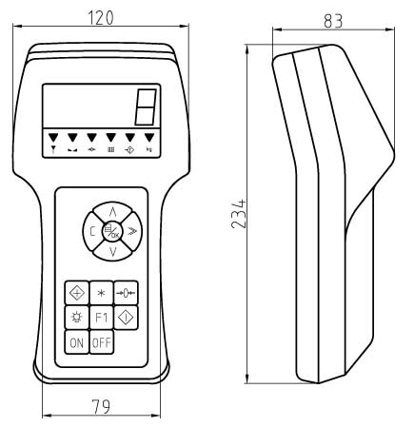 Ni-H Battery A/D conversion

**Features:**

* Adopts ∑-Δ A/D conversion technology.
* Keyboard calibration, simple operation.
* Battery charger with several protection modes to extend life of rechargeable battery.
* Handset design, ABS plastic housing.
* LCD display with EL low-power backlight.
* Adopt SMT technology, reliable and high quality.
* Records can be accumulated and searched.
* With rechargeable 4.8V/2.8AH battery for indicator, no memory. AD with power supply of DC
* 6V/4AH Ni-H battery.
* Power saving mode, indicator will turn off automatically after 30minutes with no operation.

**Main technical data：**

|  |  |
| --- | --- |
| Display | 6 digits LCD with backlight |
| Wireless Distance | Up to 200m without obstacles |
| Radio Frequency | 433MHz |
| Signal input range | -3mV～15mV |
| Load cell connection | 4 wire technique |
| Load cell excitation | DC 5V |
| Filtering | Low, Medium or High selectable |
| Resulation | 2000 to 3000 divisions standard(up to 15,000 available) |
| Zero Range | Auto/Manual setting, from 4% to 100%. |
| Tare Range | 100% F.S. |
| Overload Indication | 100% F.S. + 9e |
| Max. Safety Load | 125% F.S. |
| Ultimate Load | 400% F.S. |
| AD Battery | DC 6V/4Ah rechargeable Ni-H battery |
| Indicator Battery | 4.8V/2.8Ah rechargeable Ni-H battery |
| Battery charger | Input: AC100-240V 50/60Hz Output: 850mA |
| Operating Temperature Range | - 20℃ ~ + 50℃ |
| Operating Humidity | ≤85% RH under 20℃ |