Load cell Model: AT-1

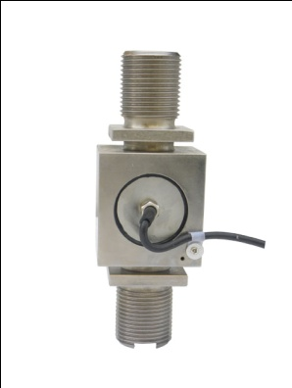 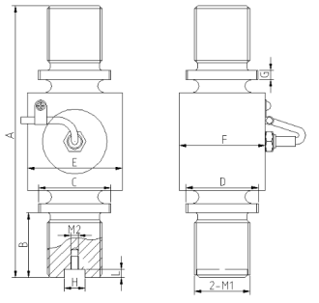

Dimensions:

|  |  |  |  |  |  |  |  |  |  |  |  |
| --- | --- | --- | --- | --- | --- | --- | --- | --- | --- | --- | --- |
| CAP（t） | A(mm) | B(mm) | C(mm) | D(mm) | E(mm) | F(mm) | G(mm) | H(mm) | L(mm) | 2-M1 | M2 |
| 5 | 206 | 50 | 55 | 45 | 66 | 45 | 7 | 15 | 6 | M36x3 | M6 |
| 10 | 206 | 50 | 55 | 55 | 72 | 65 | 7 | 16 | 6 | M42x3 | M6 |
| 20 | 248 | 60 | 55 | 55 | 92 | 65 | 8 | 20 | 6 | M52x3 | M8 |
| 50 | 350 | 100 | --- | --- | 136 | 90 | --- | 25 | 8 | M80x6 | M8 |

● High strength tension loadcell, the classic interaged structure

● Equivalent to OIML R60 C3 regulations up to  3000d for scales class III

● Protection to IP66

**Specifications**

|  |  |  |  |  |
| --- | --- | --- | --- | --- |
| Output sensitivity | mV/V | | 2 | |
| Nonlinearity | %FS | | ≤0.025 | |
| Hysteresis | %FS | | ≤0.025 | |
| Repeatability | %FS | | ≤0.01 | |
| Zero balance | %FS | | ≤1.00 | |
| Creep （in 30min） | %FS/30min | | ≤0.02 | |
| Zero Temp.coefficient | %FS/10℃ | | ≤0.04 | |
| Rated output Temp.coefficient | %FS/10℃ | | ≤0.02 | |
| Input resistance | Ω | | 385±10 | |
| Output resistance | Ω | | 350±3 | |
| Insulation resistance | MΩ | | ≥5000 | |
| Safe overload | %FS | | 150 | |
| Compensated Temp.range | ℃ | | -10～+40 | |
| Recommended Supply voltage | V | | 5～15 | |
| 4-Core shield cable 0.4 m | | Input | +： Red | -：Black |
| Output | +：Green | -：White |
| Shield | Yellow or Bare | |

**Warning**: It will affect the function of sensor to change the cable’s length!