**Digital Crane Scale**

**Dimensions and Specifications: Model: OCS-AP**

|  |  |  |  |  |  |  |  |
| --- | --- | --- | --- | --- | --- | --- | --- |
| **MODEL** | **Cap.**  **(kg)** | **Resolution**  **(kg)** | **A**  **(mm)** | **C**  **(mm)** | **H**  **(mm)** | **N.W**  **(kg)** | **OCS-SP yellowG.W.**  **(kg)** |
| **OCS-AP-0.05** | 50 | 0.02 | 34 | 25 | 370 | 4 | 5 |
| **OCS-AP-0.1** | 100 | 0.05 | 34 | 25 | 370 | 4 | 5 |
| **OCS-AP-0.2** | 200 | 0.1 | 34 | 25 | 370 | 4 | 5 |
| **OCS-AP-0.3** | 300 | 0.1 | 34 | 25 | 370 | 4 | 5 |
| **OCS-AP-0.5** | 500 | 0.2 | 42 | 27 | 390 | 4.5 | 5.5 |
| **OCS-AP-1** | 1000 | 0.5 | 42 | 27 | 390 | 4.5 | 5.5 |

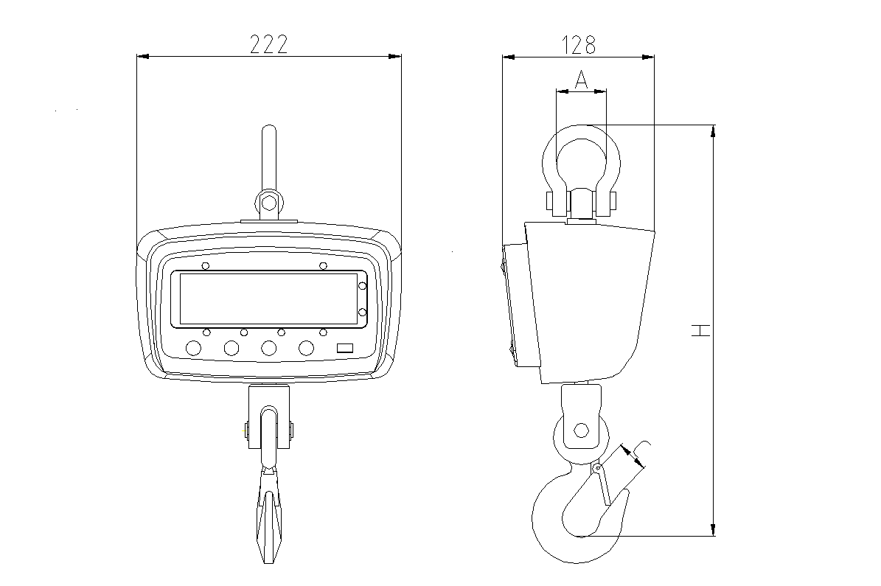**Features：**

◆**Enclosure:**

NEMA 12/IP54 powder coated Die-Casting Aluminum,

very light, easy to bring.

◆**Multi-weighing units**:

Kg, lb, N are selectable, kg are default unit.

* **Multi-function operation:**

Tare, Zero, Auto zero tracking, Total, Hold, Overload warning

and record, operated through infrared remote controller.

* **User-friendly design:**

Large red 5 digit LED display (digit height 30mm), Battery Operated with low battery indication, Automatic turn off , power-saving function.

* **Gravity regulation:**

The acceleration of gravity can be regulated through remote controller according to different places value.

* **Multi options:**

RS-232-continuous or on demand data output, user-selectable.

**Main technical data：**

|  |  |
| --- | --- |
| Accuracy Standard | According to OIML class III |
| Display | 30mm (1.2″) 5digits LCD/LED |
| Filtering | Low, Medium or High selectable |
| Units | Kilograms or Pounds or Newtons selectable |
| Resulation | 2000 to 3000 divisions standard(up to 15,000 available) |
| Zero Range | 4% F.S. |
| Tare Range | 100% F.S. |
| Overload Indication | 100% F.S. + 9e |
| Max. Safety Load | 125% F.S. |
| Ultimate Load | 400% F.S. |
| Battery Type | Fully sealed Lead-Acid battery, 6V/5Ah |
| Battery Life | ≥60 hours |
| Adapter | DC 9V/1000mA |
| Operating Temperature Range | - 20℃ ~ + 50℃ |
| Operating Humidity | ≤85% RH under 20℃ |
| Remote Controller Distance | Max. 15m |
| Battery of Remote Controller | 7# battery, 1.5Vⅹ2 |
| Acceleration of Gravity | Can be regulated, the default value is 9.793 |