**Load cell**

**Model: AS-2 Dimensions:**

|  |  |  |  |  |
| --- | --- | --- | --- | --- |
| **CAP**  **(kg)** | **A**  **(mm)** | **B**  **(mm)** | **C**  **(mm)** | **2-M** |
| 100 | 50.8 | 76.2 | 19 | M12x1.75 |
| 200 | 50.8 | 76.2 | 19 | M12x1.75 |
| 300 | 50.8 | 76.2 | 28.2 | M12x1.75 |
| 500 | 50.8 | 76.2 | 28.2 | M12x1.75 |
| 1000 | 50.8 | 76.2 | 28.2 | M12x1.75 |
| 2000 | 50.8 | 76.2 | 28.2 | M12x1.75 |
| 3000 | 86 | 106 | 34 | M18x1.5 |

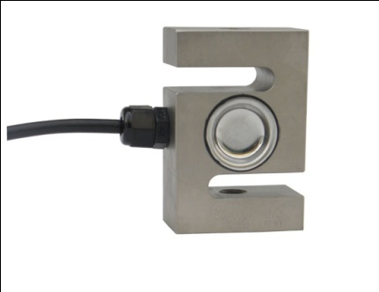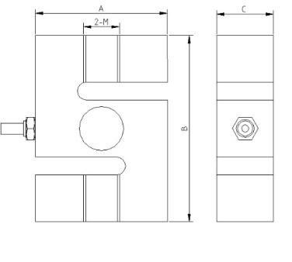

* High precision tension loadcell, the classic S type structure
* Equivalent to OIML R60 C3 regulations up to 3000d for scales class III
* Protection to IP66

**Specifications**

|  |  |  |  |
| --- | --- | --- | --- |
| Output sensitivity | mV/V | 2 | |
| Nonlinearity | %FS | ≤0.025 | |
| Hysteresis | %FS | ≤0.025 | |
| Repeatability | %FS | ≤0.01 | |
| Zero balance | %FS | ≤1.00 | |
| Creep （in 30min） | %FS/30min | ≤0.02 | |
| Zero Temp.coefficient | %FS/10℃ | ≤0.04 | |
| Rated output Temp.coefficient | %FS/10℃ | ≤0.02 | |
| Input resistance | Ω | 385±10 | |
| Output resistance | Ω | 350±3 | |
| Insulation resistance | MΩ | ≥5000 | |
| Safe overload | %FS | 150 | |
| Compensated Temp.range | ℃ | -10～+40 | |
| Recommended Supply voltage | V | 5～15 | |
| 4-Core shield cable 0.2 m | Input | +： Red | -：Black |
| Output | +：Green | -：White |
| Shield | Yellow or Bare | |

**Warning**: It will affect the function of sensor to change the cable’s length!