**Wireless indicator**

**Model: 68DT Accessories:**

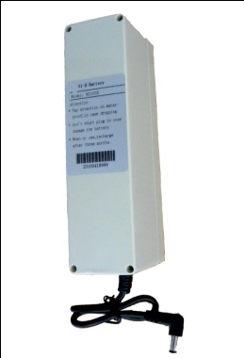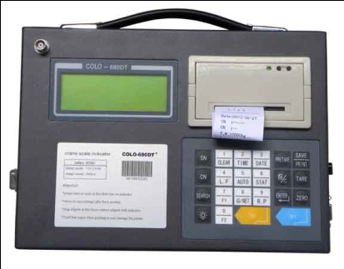 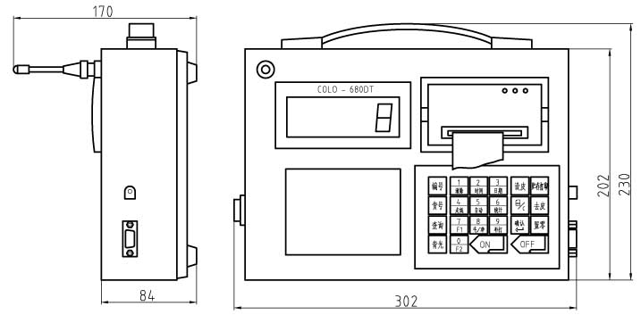

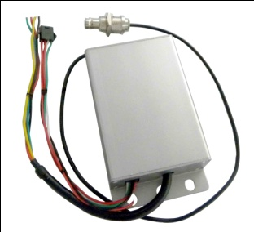**Features:**

* Adopts ∑-Δ A/D conversion technology.
* Keyboard calibration, easy to operate.
* Able to setup zero(auto/manual) range.
* Weighing data save protection in case of power off.
* Battery charger with several protection modes to extend life of rechargeable battery.
* Standard RS232 communication interface(optional).
* Portable design, packed in portable box, easy to operate outdoor.
* Adopt SMT technology, reliable and high quality.
* LCD display with dot character with backlight, readable in aphotic areas.
* Gathering up to data records of 2000 weighings, records can be sorted, searched and printed.
* Standard parallel print interface(EPSON printer).
* With rechargeable 7.2V/2.8AH battery for indicator, no memory. Scale body with power supply of DC 6V/4AH

battery.

* Power saving mode, indicator will turn off automatically after 30minutes with no operation.

**Main technical data：**

|  |  |
| --- | --- |
| Display | Matrix LCD with backlight |
| Wireless Distance | Up to 200m without obstacles |
| Radio Frequency | 433MHz |
| Signal input range | -3mV～15mV |
| Load cell connection | 4 wire technique |
| Load cell excitation | DC 5V |
| Filtering | Low, Medium or High selectable |
| Resulation | 2000 to 3000 divisions standard(up to 15,000 available) |
| Zero Range | Auto/Manual setting, from 4% to 100%. |
| Tare Range | 100% F.S. |
| Overload Indication | 100% F.S. + 9e |
| Max. Safety Load | 125% F.S. |
| Ultimate Load | 400% F.S. |
| AD Battery | DC 6V/4Ah rechargeable Ni-H battery |
| Indicator Battery | 7.2V/2.8Ah rechargeable Ni-H battery |
| Battery charger | Input: AC100-240V 50/60Hz Output: 850mA |
| Operating Temperature Range | - 20℃ ~ + 50℃ |
| Operating Humidity | ≤85% RH under 20℃ |