**OCS-AWL(Digital crane scale OCS-A with wireless systems)**

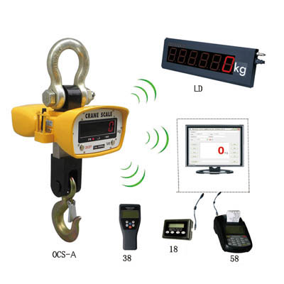**Dimensions and Specifications:**

|  |  |  |  |  |  |  |  |  |
| --- | --- | --- | --- | --- | --- | --- | --- | --- |
| **MODEL** | **Cap.**  **(kg)** | **Resolution**  **(kg)** | **A**  **(mm)** | **B**  **(mm)** | **C**  **(mm)** | **H**  **(mm)** | **N.W**  **(kg)** | **G.W.**  **(kg)** |
| **OCS-AWL-1** | 1000 | 0.5 | 80 | 340 | 30 | 420 | 12 | 16 |
| **OCS-AWL-2** | 2000 | 1 | 80 | 340 | 30 | 420 | 12 | 16 |
| **OCS-AWL-3** | 3000 | 1 | 100 | 340 | 40 | 600 | 14 | 19 |
| **OCS-AWL-5** | 5000 | 2 | 130 | 360 | 45 | 720 | 25 | 30 |
| **OCS-AWL-10** | 10000 | 5 | 145 | 360 | 60 | 850 | 40 | 45 |
| **OCS-AWL-15** | 15000 | 5 | 170 | 360 | 85 | 900 | 75 | 80 |
| **OCS-AWL-20** | 20000 20000 | 10 | 190 | 360 | 85 | 1000 | 80 | 85 |

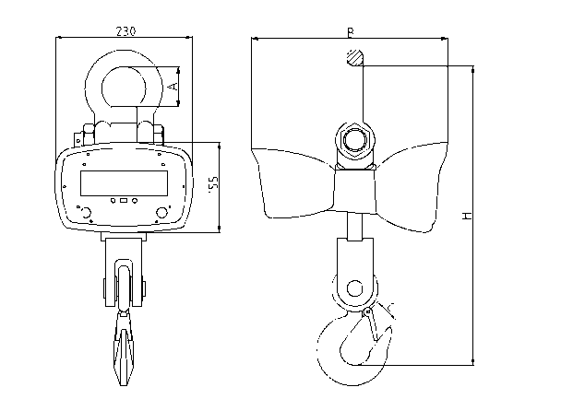**Features：**

* **Enclosure:** NEMA 12/IP54 powder coated Foundry Cast Aluminum.
* **Accuracy:** According to OIML class III.
* **Display:** 30mm (1.2″) 5digits LCD/LED.
* **Battery:** Fully sealed Lead-Acid battery, 6V/7Ah, can reach 70hours

continuous working.

* **Adapter:** DC 9V/1000mA
* **Ultimate Load:** 400% of capacity.
* **Operation temperature:** -20℃ to 50℃
* **Gravity regulation:** The acceleration of gravity can be regulated

through wireless indicator according to different places value.

**Our crane scale model OCS-AL, OCS-AP, OCS-AX, OCS-AH also can connect with these wireless systems.**

**Model :OCS-A1(crane scale OCS-A + 18 indicator) features**

|  |  |  |
| --- | --- | --- |
| **Palm-size** | **28x70x90**mm shell with LCD display, wireless double-sided communication(can tare, zero, calibration and parameter setting). 5 digits LCD display with backlight，digit height：12mm. Many function on LCD display( battery power, TARE, ZERO, PEAK, Stable) . | |
| **USB port** | communicate with PC,Solve many laptops without serial port problem.with the Everight company’s PC host computer software, not only display weigh value and stable information on the PC , also can input company’s name, complete storage ,print query and other function. | |
| **Power supply** | | USB power supply, lithium battery optional . |
| **Operating temperature** | | -20℃ to 60℃ |
| **Antenna** | | Intergral antenna |
| **Update rate from scale** | | 4 times per second. |
| **Radio Frequency** | Standard 433MHz wireless module, up to 200m wireless distance，up to 32 channels available.（868MHz,2.4Ghz wireless module optional）. | |

**Model: OCS-A3( crane scale OCS-A + 38 indicator) features**

|  |  |  |  |
| --- | --- | --- | --- |
| **Instrument size** | 220x105x50mm handheld size with LCD display, wireless double-sided communication(can tare,zero,calibration and parameter setting). 5 digits LCD display with backlight，digit height：25mm. Many functions on instrument keyboard. Such as tare, zero, peak, filter setting, gravity regulation. | | |
| **Battery** | 4pcs AA size alkaline battreies, 40 hours radio continuous using | | |
| **RS-232 communication** | | Print or exact data easily. Continuous output can drive a scoreboard.（optional） | |
| **Operating temperature** | | | -20℃ to 60℃ |
| **Antenna** | | | Intergral antenna |
| **Update rate from scale** | | | 4 times per second. |
| **Radio Frequency** | Standard 433MHz wireless module, up to 200m wireless distance，up to 36 channels available.（868MHz,2.4Ghz wireless module optional）. | | |

**Model: OCS-A5( crane scale OCS-A + 58 indicator) features**

|  |  |  |  |  |
| --- | --- | --- | --- | --- |
| **Instrument size** | **220X128X90**mm**,** the latest design, compatible with the concept of portable, print and easy to operate. Shoulder bag style leather case,easy to carry, suitable for protected outdoor use. | | | |
| **Display** | Wireless double-sided communication, 5 digits LCD display with backlight，digit height：25mm. Many functions on LCD display( battery power,TARE,ZERO,PEAK,Stable) . | | | |
| **Communications** | | | Both RS232 serial port and USB port，solve most laptops without serial port problem. with the Everight company’s PC host computer software,not only display weigh value and stable information on the PC ,can also enter company’s name,complete storage ,print query and other functions . | |
| **Battery** | | | High performance, 3500mAh SC type industrial Ni-H batteries, repeatedly charging times can reach 1000times, one time charge can work 50 hours under typical use. | |
| **Operating temperature** | | | | -20℃ to 60℃ |
| **Antenna** | | | | Intergral antenna |
| **Update rate from scale** | | | | 4 times per second. |
| **Printer** | | | | FUJITSU FTP-608 2″ high speed thermal printer |
| **CPU** | | ARM-based 32-bit MCU,combines with high performance,real time capabilities, and low power, low voltage operation. | | |
| **Function on keyboard** | | It can print data,time,Serial number, commodity number,net weight and total weight. Also can input 16 digits head information,It can store up to 2000 weighing records.It can be statistics by serial number or commodity number，also can statistics by data, statistical results can be printed with weighing number and total weight. | | |
| **Radio Frequency** | | Standard 433MHz wireless module, up to 200m wireless distance，up to 36 channels available.（868MHz, 2.4Ghz wireless module optional） | | |

**Model: OCS-ALD(crane scale OCS-A + Large display) specification:**

|  |  |
| --- | --- |
| **Display size** | 75mm (3″) 6digits LED. Size: 540x180x55mm  125mm(5″) 6digits LED. Size: 780x260x58mm |
| **RS-232 communication** | Print or exact data easily.（optional） |
| **Power supply** | AC 187-242V, 50/60Hz |
| **Operatiing temperature** | -20℃ to 60℃ |
| **Update rate from scale** | 4 times per second. |
| **Radio Frequency** | Standard 433MHz wireless module, up to 200m wireless distance，up to 32 channels available.（868MHz,2.4Ghz wireless module optional）. |