**Wireless handheld indicator**

**Model: 38**

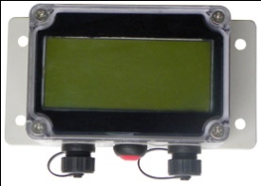 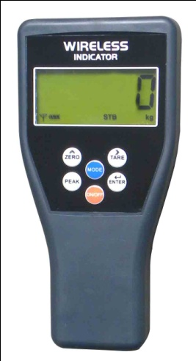 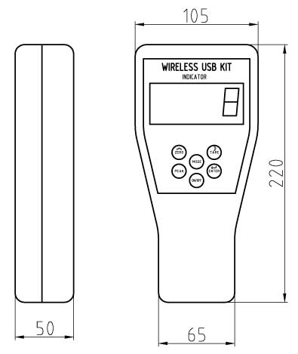

**Transmitter Receiver**

**Features：**

* **Instrument size:** 220x105x50mm handheld size with LCD display, portable, wireless double-sided communication. 5 digits LCD display with backlight，digit height：25mm. Many functions on instrument keyboard. Such as tare, zero, peak, filter setting, gravity regulation.
* Calibration: Keyboard calibration and parameter setting, simple operation.  
  **Battery:** 4pcs AA size alkaline batteries, 50 hours radio continuous using.
* **Set-point:** one user programmable Set-Point can be used for safety and warning applications or for limit weighing.
* **RS-232 communication:** Print or exact data easily. Continuous output can drive a scoreboard.
* **Operatiing temperature:** -20℃ to 60℃
* **Antenna:** Intergral antenna
* **Update rate from loadcell:** 12 times per second.
* **Radio Frequency:** Standard 2.4GHz wireless module, up to 70m wireless distance，up to 128 channels available.（433MHz, 868MHz wireless module optional）.