Heat Proof Digital Crane Scale
Dimensions and Specifications: Model: OCS-AH
MODEL | Cap.  (kg) | Resolution  (kg) | A  (mm) | C  (mm) | H  (mm) | N.W  (kg) | 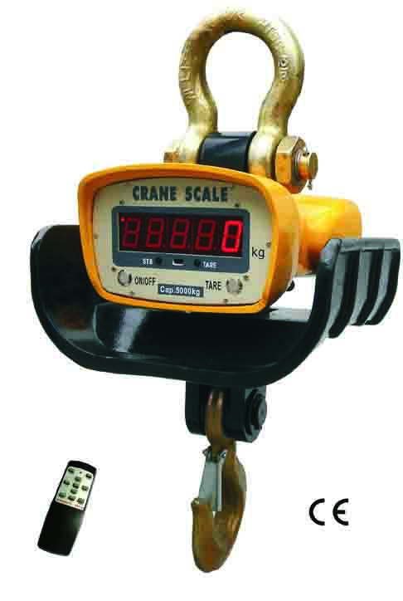  G.W.  (kg)
OCS-AH-1 | 1000 | 0.5 | 100 | 40 | 600 | 24 | 27
OCS-AH-2 | 2000 | 1 | 100 | 40 | 600 | 24 | 27
OCS-AH-3 | 3000 | 1 | 130 | 45 | 720 | 33 | 36
OCS-AH-5 | 5000 | 2 | 145 | 60 | 850 | 50 | 55
OCS-AH-10 | 10000 | 5 | 170 | 85 | 900 | 75 | 78
OCS-AH-15 | 15000 | 5 | 190 | 85 | 920 | 80 | 86
Min distance between scale and high temperature:
1000℃ | 1200℃ | 1400℃ | 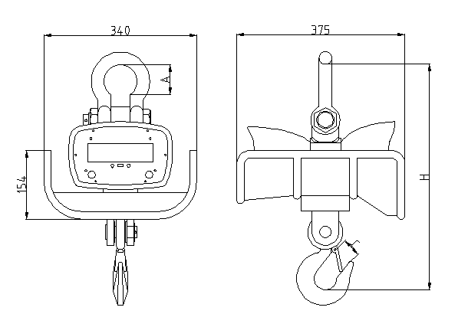  1600℃
1.6m | 1.8m | 2m | 2.2m
Features：
◆Enclosure:
NEMA 12/IP54 powder coated Foundry Cast Aluminum
◆Multi-weighing units: Kg, lb are selectable, kg are default unit
- Multi-function operation:
Tare, Zero, Auto zero tracking, Total, Hold, Overload warning
and record, operated through infrared remote controller.
- User-friendly design:
Large red 5 digit LED display (digit height 30mm), Battery Operated with low battery indication, Automatic turn off , power-saving function.
- Gravity regulation:
The acceleration of gravity can be regulated through remote controller according to different places value.
- Multi options:
RS-232-continuous or on demand data output, user-selectable.
Wireless big screen 3″, 5″, wireless indicator 18, 28, 38, 58 can match with the scale, user-selectable.
Main technical data：
Accuracy Standard | According to OIML class III
Display | 30mm (1.2″) 5digits LCD/LED
Filtering | Low, Medium or High selectable
Units | Kilograms or Pounds selectable
Resulation | 2000 to 3000 divisions standard(up to 15,000 available)
Zero Range | 4% F.S.
Tare Range | 100% F.S.
Overload Indication | 100% F.S. + 9e
Max. Safety Load | 125% F.S.
Ultimate Load | 400% F.S.
Battery Type | Fully sealed Lead-Acid battery, 6V/7Ah
Battery Life | ≥70 hours
Adapter | DC 9V/1000mA
Operating Humidity | ≤85% RH under 20℃
Remote Controller Distance | Max. 15m
Battery of Remote Controller | 7# battery, 1.5Vⅹ2
Acceleration of Gravity | Can be regulated, the default value is 9.793

