**Wireless Crane Scale**

**Dimensions and Specifications: Model: OCS-AWL2**

|  |  |  |  |  |  |  |  |  |
| --- | --- | --- | --- | --- | --- | --- | --- | --- |
| **MODEL** | **Cap.**  **(kg)** | **Resolution**  **(kg)** | **A**  **(mm)** | **C**  **(mm)** | **E**  **(mm)** | **H**  **(mm)** | **Φ**  **(mm)** | **OCS-SWL2G.W.**  **(kg)** |
| **OCS-AWL2-1** | 1000 | 0.5 | 95 | 33 | 145 | 445 | 270 | 30 |
| **OCS-AWL2-2** | 2000 | 1 | 95 | 33 | 145 | 445 | 270 | 30 |
| **OCS-AWL2-3** | 3000 | 1 | 95 | 40 | 145 | 445 | 270 | 31 |
| **OCS-AWL2-5** | 5000 | 2 | 120 | 50 | 155 | 485 | 298 | 42 |
| **OCS-AWL2-10** | 10000 | 5 | 124 | 60 | 170 | 655 | 325 | 52 |
| **OCS-AWL2-15** | 15000 | 5 | 225 | 70 | 170 | 855 | 325 | 72 |
| **OCS-AWL2-20** | 20000 20000 | 10 | 225 | 85 | 170 | 920 | 325 | 82 |
| **OCS-AWL2-30** | 30000 20000 | 10 | 260 | 105 | 200 | 1055 | 375 | 122 |

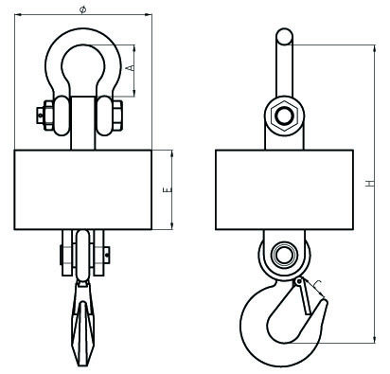

**Features：**

* Seamless steel pipe enclosure for maximum protection.
* Manu operation mode, calibration, saving, searching, peak hold, easy to

operate.

* Indicator Adopts ∑-Δ A/D conversion technology.
* Weighing data save protection in case of power off.
* Battery charger with several protection modes to extend life of rechargeable battery.
* Standard RS232 communication interface(optional).
* Portable design, indicator packed in portable carry case, easy to operate

outdoor.

* Gathering up to data records of 99 weighings, records can be sorted, searched .
* Power saving mode, indicator will turn off automatically after 30minutes with no operation.
* With 32 channels optional, so 32 crane scales can operated independently in the same airplace without interface.

**Main technical data：**

|  |  |
| --- | --- |
| Accuracy Standard | According to OIML class III |
| Display | LCD with backlight |
| Wireless Distance | Up to 200m without obstacle |
| Filtering | Low, Medium or High selectable |
| Resulation | 2000 to 3000 divisions standard(up to 15,000 available) |
| Zero Range | Auto/Manual setting, from 4% to 100%. |
| Tare Range | 100% F.S. |
| Overload Indication | 100% F.S. + 9e |
| Max. Safety Load | 125% F.S. |
| Ultimate Load | 400% F.S. |
| Scale Battery Type | DC 6V/7Ah rechargeable Lead-Acid battery |
| Indicator Battery | 6V/4.5Ah rechargeable Lead-Acid battery |
| Battery charger | Input: AC100-240V 50/60Hz Output: 850mA |
| Operating Temperature Range | - 20℃ ~ + 50℃ |
| Operating Humidity | ≤85% RH under 20℃ |
| Radio Frequency | 433MHz |