**Wireless Dynamometer**

**Model: AL-W3**

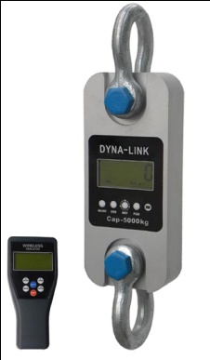 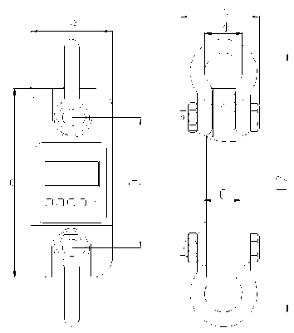

**DIMENSIONS*(Dimensions shown are nominal and subject to tolerances)***

|  |  |  |  |  |  |  |  |  |  |
| --- | --- | --- | --- | --- | --- | --- | --- | --- | --- |
| MODEL | CAP | Div | A(mm) | B(mm) | C(mm) | D(mm) | φ(mm) | H(mm) | Material |
| AL-W3-1 | 1t | 0.5kg | 245 | 112 | 37 | 190 | 43 | 335 | Aluminum |
| AL-W3-2 | 2t | 1kg | 260 | 123 | 37 | 195 | 51 | 365 | Aluminum |
| AL-W3-3 | 3t | 1kg | 260 | 123 | 37 | 195 | 51 | 365 | Aluminum |
| AL-W3-5 | 5t | 2kg | 285 | 123 | 57 | 210 | 58 | 405 | Aluminum |
| AL-W3-10 | 10t | 5kg | 320 | 120 | 57 | 230 | 92 | 535 | Alloy Steel |
| AL-W3-20 | 20t | 10kg | 375 | 128 | 74 | 260 | 127 | 660 | Alloy Steel |
| AL-W3-30 | 30t | 10kg | 420 | 138 | 82 | 280 | 146 | 740 | Alloy Steel |
| AL-W3-50 | 50t | 20kg | 465 | 150 | 104 | 305 | 184 | 930 | Alloy Steel |
| AL-W3-100 | 100t | 50kg | 570 | 190 | 132 | 366 | 229 | 1230 | Alloy Steel |
| AL-W3-200 | 200t | 100kg | 720 | 265 | 183 | 440 | 280 | 1362 | Alloy Steel |

**WEIGHTS**

|  |  |  |  |  |  |
| --- | --- | --- | --- | --- | --- |
| **Model** | AL-W3-1 | AL-W3-2 | AL-W3-3 | AL-W3-5 | AL-W3-10 |
| **Unit Weight(kg)** | 1.6 | 2.1 | 2.1 | 2.7 | 10.4 |
| **Weight with shackles(kg)** | 3.1 | 4.6 | 4.6 | 6.3 | 24.8 |
| **Model** | AL-W3-20 | AL-W3-30 | AL-W3-50 | AL-W3-100 | AL-W3-200 |
| **Unit Weight(kg)** | 17.8 | 25 | 39 | 81 | 210 |
| **Weight with shackles(kg)** | 48.6 | 73 | 128 | 321 | 776 |

**Profile:**

AL-W3 wireless dynamometer is an extremely well-built instrument for industry use ,as a standard wireless tool offer universal applications,Whether used as conventional crane weigher or to measure force, AL-W3 wireless dynamometer is microprocessor controlled for high precision accuracy, calibration is easier with wireless handheld indicator 38.

**Features:**

* **Body protection:** Aluminum and alloy steel capacities are powder coated.
* **Accuracy:** 0.05% for 1-50t, 0.1% for above 50t capacity.
* **Units:** Units are clearly display on the screen**,** available in the following measurment reading: kilograms(kg), short Tons(t) pounds(lb), Newton and kilonewton(kN)
* **Shackles:** High tension industrial standard G2130 anchor shackle bows, galvanized finish.
* **Gravity regulation:** The acceleration of gravity can be regulated through indicator parameter setting according to different places value.
* **Functions:** wireless indicator with many functions: Zero, tare, Low battery warnings, peak hold, overload warning. User calibration(with password).
* **Set-Point:** Two user programmable Set-Point can be used for safety and warning applications or for limit weighing.
* **Package:** Packed with carry case, easy to bring.
* **Indicator key:** 4 local mechanical keys:”ON/OFF”,”ZERO”,”PEAK” and ”Unit Change”.

**Main technical data:**

|  |  |
| --- | --- |
| Body Display | 25mm (1’’) 5digits LCD with backlight |
| 38 Indicator Display | 25mm (1’’) 5digits LCD with backlight |
| Power on zero range | 20% F.S. |
| Manual Zero Range | 4% F.S. |
| Tare Range | 100% F.S. |
| Stable Time | ≤5 seconds |
| Overload Indication | 100% F.S. + 9e |
| Max. Safety Load | 125% F.S. |
| Ultimate Load | 400% F.S. |
| Battery Life | ≥50 hours |
| Body Battery | “LR6(AA)”size alkaline batteries. 1.5Vⅹ3 |
| Indicator Battery | “LR6(AA)”size alkaline batteries. 1.5Vⅹ4 |
| Operating Temp. | - 20℃ ~ + 50℃ |
| Operating Humidity | ≤85% RH under 20℃ |
| Wireless Distance | Min. 80m(default) [200m(optional)] |
| Wireless Frequency | 2.4GHz(default),433MHz,868MHz(optional) |