**Digital Dynamometer with wireless systems(AL-WLS)**

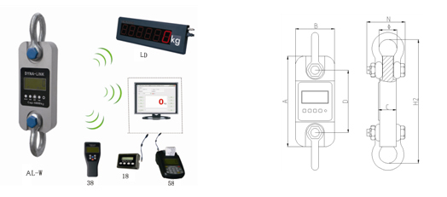

**DIMENSIONS*(Dimensions shown are nominal and subject to tolerances)***

|  |  |  |  |  |  |  |  |  |  |
| --- | --- | --- | --- | --- | --- | --- | --- | --- | --- |
| MODEL | CAP | Div | A(mm) | B(mm) | C(mm) | D(mm) | φ(mm) | H(mm) | Material |
| AL-WLS-1 | 1t | 0.5kg | 245 | 112 | 37 | 190 | 43 | 335 | Aluminum |
| AL-WLS-2 | 2t | 1kg | 260 | 123 | 37 | 195 | 51 | 365 | Aluminum |
| AL-WLS-3 | 3t | 1kg | 260 | 123 | 37 | 195 | 51 | 365 | Aluminum |
| AL-WLS-5 | 5t | 2kg | 285 | 123 | 57 | 210 | 58 | 405 | Aluminum |
| AL-WLS-10 | 10t | 5kg | 320 | 120 | 57 | 230 | 92 | 535 | Alloy Steel |
| AL-WLS-20 | 20t | 10kg | 375 | 128 | 74 | 260 | 127 | 660 | Alloy Steel |
| AL-WLS-30 | 30 | 10kg | 420 | 138 | 82 | 280 | 146 | 740 | Alloy Steel |
| AL-WLS-50 | 50t | 20kg | 465 | 150 | 104 | 305 | 184 | 930 | Alloy Steel |
| AL-WLS-100 | 100t | 50kg | 570 | 190 | 132 | 366 | 229 | 1230 | Alloy Steel |
| AL-WLS-200 | 200t | 100kg | 720 | 265 | 183 | 440 | 280 | 1362 | Alloy Steel |

**WEIGHTS**

|  |  |  |  |  |  |  |  |  |  |  |
| --- | --- | --- | --- | --- | --- | --- | --- | --- | --- | --- |
| **Model** | AL-WLS  -1 | AL-WLS  -2 | AL-WLS  -3 | AL-WLS  -5 | AL-WLS  -10 | AL-WLS  -20 | AL-WLS  -30 | AL-WLS  -50 | AL-WLS  -100 | AL-WLS  -200 |
| **Unit Weight(kg)** | 1.6 | 2.1 | 2.1 | 2.7 | 10.4 | 17.8 | 25 | 39 | 81 | 210 |
| **Weight with shackles(kg)** | 3.1 | 4.6 | 4.6 | 6.3 | 24.8 | 48.6 | 73 | 128 | 321 | 776 |

**Features:**

* **Body protection:** Aluminum and alloy steel capacities are powder coated.
* **Accuracy:** 0.05% for 1-50t, 0.1% for above 50t capacity.
* **Units:** Available in the following measurement reading: kilograms(kg), short Tons(t) pounds(lb), Newton and kilonewton(kN)
* **Battery:** 3pcs AA size alkaline batteries, 50 hours radio continuous using.
* **Body Display:** 25mm (1″) 5digits LCD with backlight for easy distant viewing.
* **Shackles:** High tension industrial standard G2130 anchor shackle bows, galvanized finish.
* **Ultimate Load:** 400% of capacity.
* **Operation temperature:** -20℃ to 50℃
* **Gravity regulation:** The acceleration of gravity can be regulated through wireless indicator according to different places value.
* **Functions:** Zero, tare, Low battery warnings, peak hold, two user programmable Set-Point can be used for safety and warning applications or for limit weighing. User calibration.