**Load cell**

**Model: AS-3**

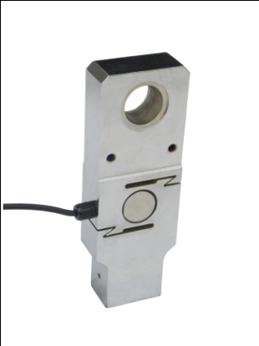 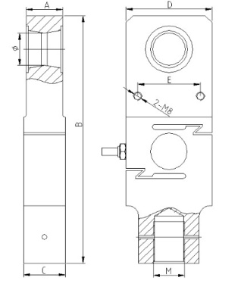

**Dimensions:**

|  |  |  |  |  |  |  |  |
| --- | --- | --- | --- | --- | --- | --- | --- |
| **CAP(t)** | **A(mm)** | **B(mm)** | **C(mm)** | **D(mm)** | **E(mm)** | Φ(mm) | **M** |
| 3 | 30 | 215 | 30 | 70 | 50 | 25 | M24x2 |
| 5 | 35 | 237 | 40 | 82 | 60 | 31 | M30x2 |
| 10 | 49 | 263 | 52 | 92 | 70 | 36 | M39x3 |

* High precision tension loadcell, the classic S type structure
* Equivalent to OIML R60 C3 regulations up to  3000d for scales class III
* Protection to IP66

**Specifications**

|  |  |  |  |
| --- | --- | --- | --- |
| Output sensitivity | mV/V | 2 | |
| Nonlinearity | %FS | ≤0.025 | |
| Hysteresis | %FS | ≤0.025 | |
| Repeatability | %FS | ≤0.01 | |
| Zero balance | %FS | ≤1.00 | |
| Creep （in 30min） | %FS/30min | ≤0.02 | |
| Zero Temp.coefficient | %FS/10℃ | ≤0.04 | |
| Rated output Temp.coefficient | %FS/10℃ | ≤0.02 | |
| Input resistance | Ω | 385±10 | |
| Output resistance | Ω | 350±3 | |
| Insulation resistance | MΩ | ≥5000 | |
| Safe overload | %FS | 150 | |
| Compensated Temp.range | ℃ | -10～+40 | |
| Recommended Supply voltage | V | 5～15 | |
| 4-Core shield cable 0.3 m | Input | +： Red | -：Black |
| Output | +：Green | -：White |
| Shield | Yellow or Bare | |

**Warning**: It will affect the function of sensor to change the cable’s length!