**Load cell**

**Model: ALT-1**

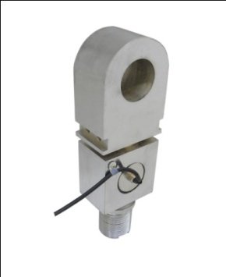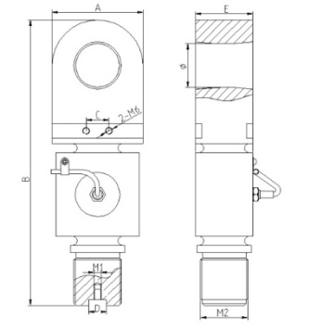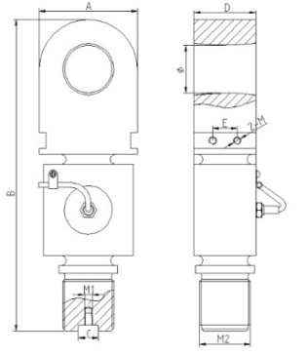

**10t 20t, 30t**

**Dimensions:**

|  |  |  |  |  |  |  |  |  |  |
| --- | --- | --- | --- | --- | --- | --- | --- | --- | --- |
| **CAP**  **(t)** | **A**  **(mm)** | **B**  **(mm)** | **C**  **(mm)** | **D**  **(mm)** | **E**  **(mm)** | Φ  (mm) | **2-M** | **M1** | **M2** |
| 10 | 75 | 253 | 20 | 16 | 56 | 37 | M6 | M6 | M42x3 |
| 20 | 100 | 314 | 20 | 63 | 25 | 48 | M8 | M8 | M52x3 |
| 30 | 120 | 370 | 25 | 70 | 45 | 58 | M10 | M10 | M60x3 |

* High strength tension loadcell, the classic interaged structure
* Equivalent to OIML R60 C3 regulations up to  3000d for scales class III
* Protection to IP66

**Specifications**

|  |  |  |  |
| --- | --- | --- | --- |
| Output sensitivity | mV/V | 2 | |
| Nonlinearity | %FS | ≤0.025 | |
| Hysteresis | %FS | ≤0.025 | |
| Repeatability | %FS | ≤0.01 | |
| Zero balance | %FS | ≤1.00 | |
| Creep （in 30min） | %FS/30min | ≤0.02 | |
| Zero Temp.coefficient | %FS/10℃ | ≤0.04 | |
| Rated output Temp.coefficient | %FS/10℃ | ≤0.02 | |
| Input resistance | Ω | 385±10 | |
| Output resistance | Ω | 350±3 | |
| Insulation resistance | MΩ | ≥5000 | |
| Safe overload | %FS | 150 | |
| Compensated Temp.range | ℃ | -10～+40 | |
| Recommended Supply voltage | V | 5～15 | |
| 4-Core shield cable 0.4 m | Input | +： Red | -：Black |
| Output | +：Green | -：White |
| Shield | Yellow or Bare | |

**Warning**: It will affect the function of sensor to change the cable’s length!