**Load cell**

|  |  |  |  |  |  |
| --- | --- | --- | --- | --- | --- |
| **CAP**  **(t)** | **A**  **(mm)** | **B**  **(mm)** | **C**  **(mm)** | **D**  **(mm)** | 2-Φ  (mm) |
| 5 | 190 | 55 | 30 | 137 | 27 |
| 10 | 245 | 70 | 36 | 168 | 41 |
| 20 | 312 | 94 | 45 | 206 | 54 |
| 30 | 370 | 114 | 50 | 246 | 60 |
| 50 | 460 | 140 | 60 | 309 | 73 |
| 100 | 580 | 180 | 80 | 389 | 99 |
| 150 | 690 | 220 | 90 | 456 | 112 |
| 200 | 800 | 250 | 100 | 534 | 134 |

**Model: AB-1 Dimensions:**

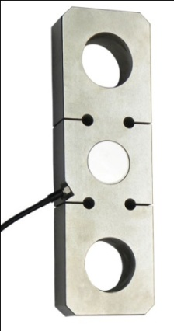 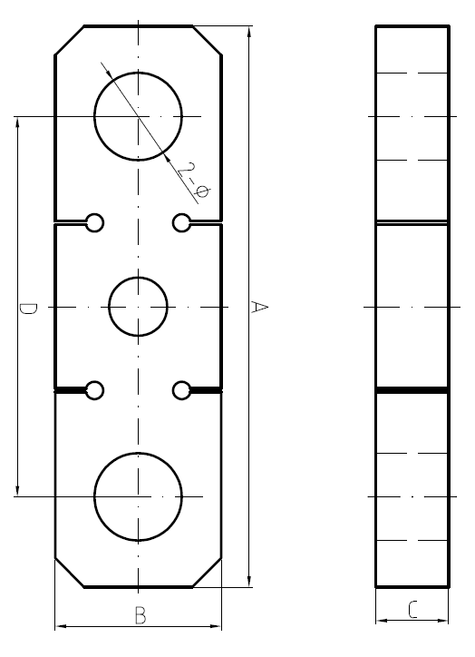

* High precision tension loadcell
* Equivalent to OIML R60 C3 regulations up to 3000d for scales class III
* Protection to IP66

**Specifications**

|  |  |  |  |
| --- | --- | --- | --- |
| Output sensitivity | mV/V | 2.0 | |
| Nonlinearity | %FS | ≤0.03 | |
| Hysteresis | %FS | ≤0.03 | |
| Repeatability | %FS | ≤0.02 | |
| Zero balance | %FS | ≤1.00 | |
| Creep （in 30min） | %FS/30min | ≤0.02 | |
| Zero Temp.coefficient | %FS/10℃ | ≤0.04 | |
| Rated output Temp.coefficient | %FS/10℃ | ≤0.02 | |
| Input resistance | Ω | 385±10 | |
| Output resistance | Ω | 350±3 | |
| Insulation resistance | MΩ | ≥5000 | |
| Safe overload | %FS | 150 | |
| Compensated Temp.range | ℃ | -10～+40 | |
| Recommended Supply voltage | V | 5～15 | |
| 4-Core shield cable 3 m | Input | +： Red | -：Black |
| Output | +：Green | -：White |
| Shield | Yellow or Bare | |

**Warning**: It will affect the function of sensor to change the cable’s length!